**Name:M.K.Vishnupriyan**

**Reg.No:73772121222**

**Department:Information Technology**

**Micro Project:Employee Management System**

Output:

1. Frontend Page:

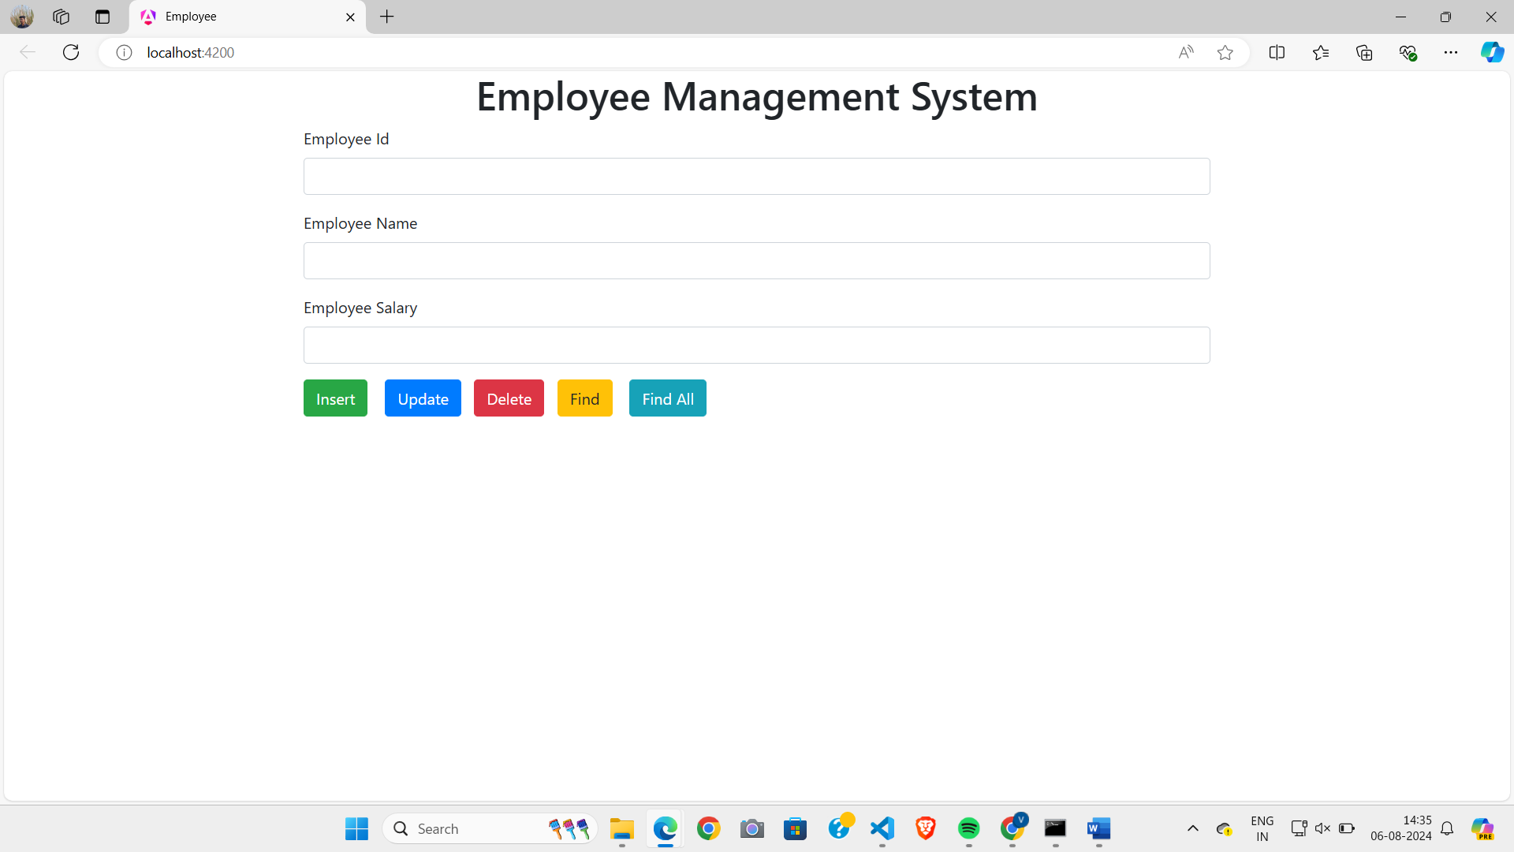

1. Adding data to Database:

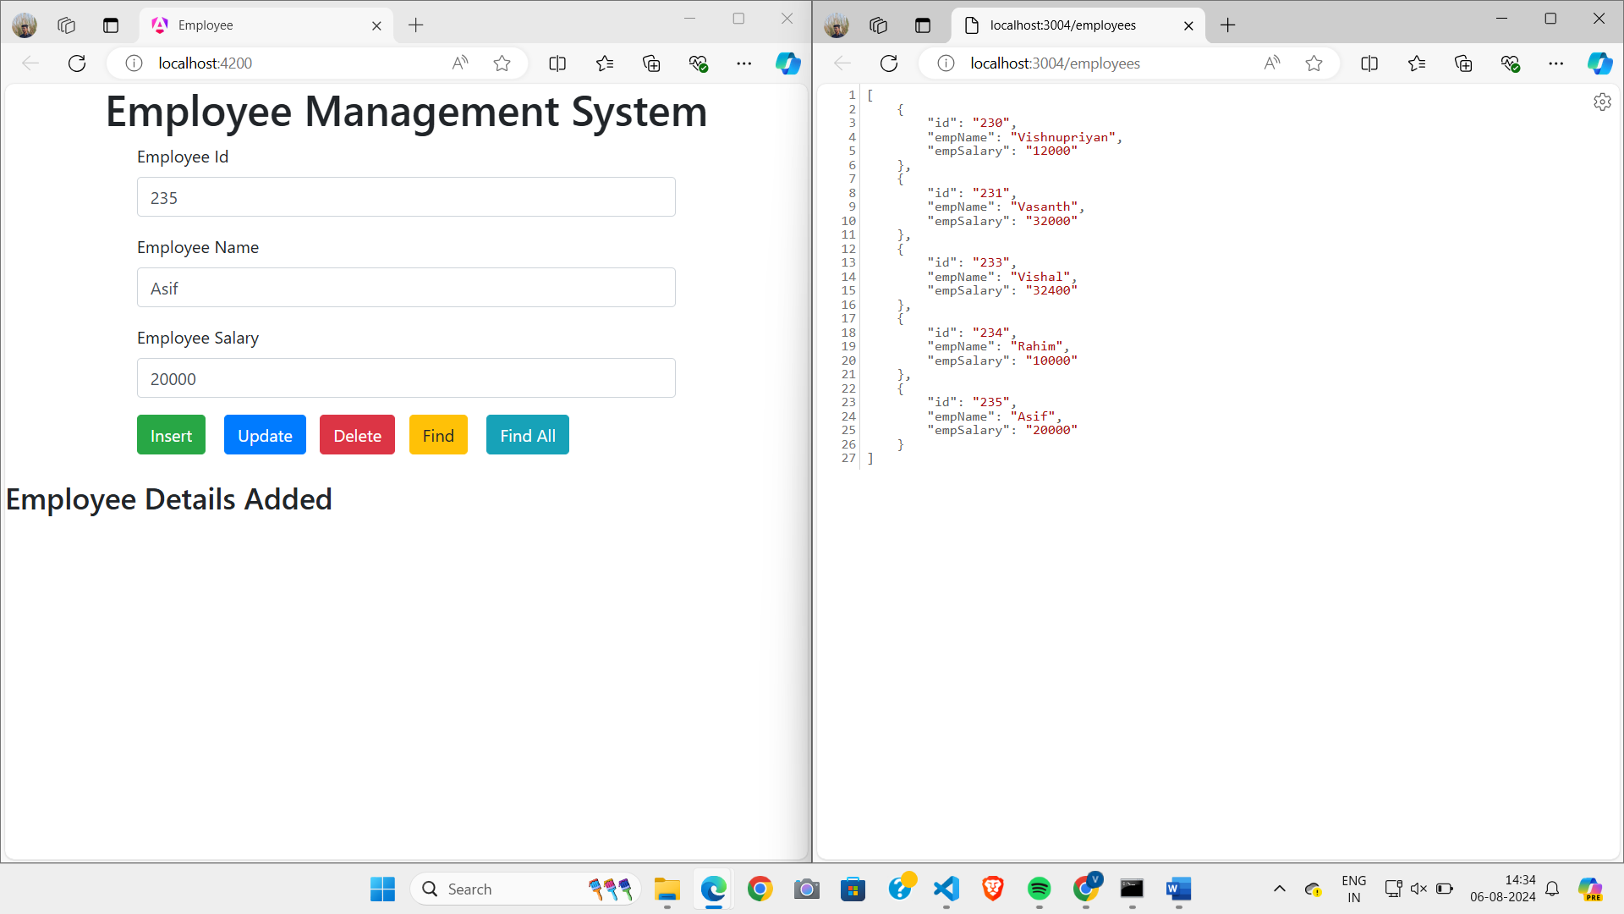

3)Update the 5th data:

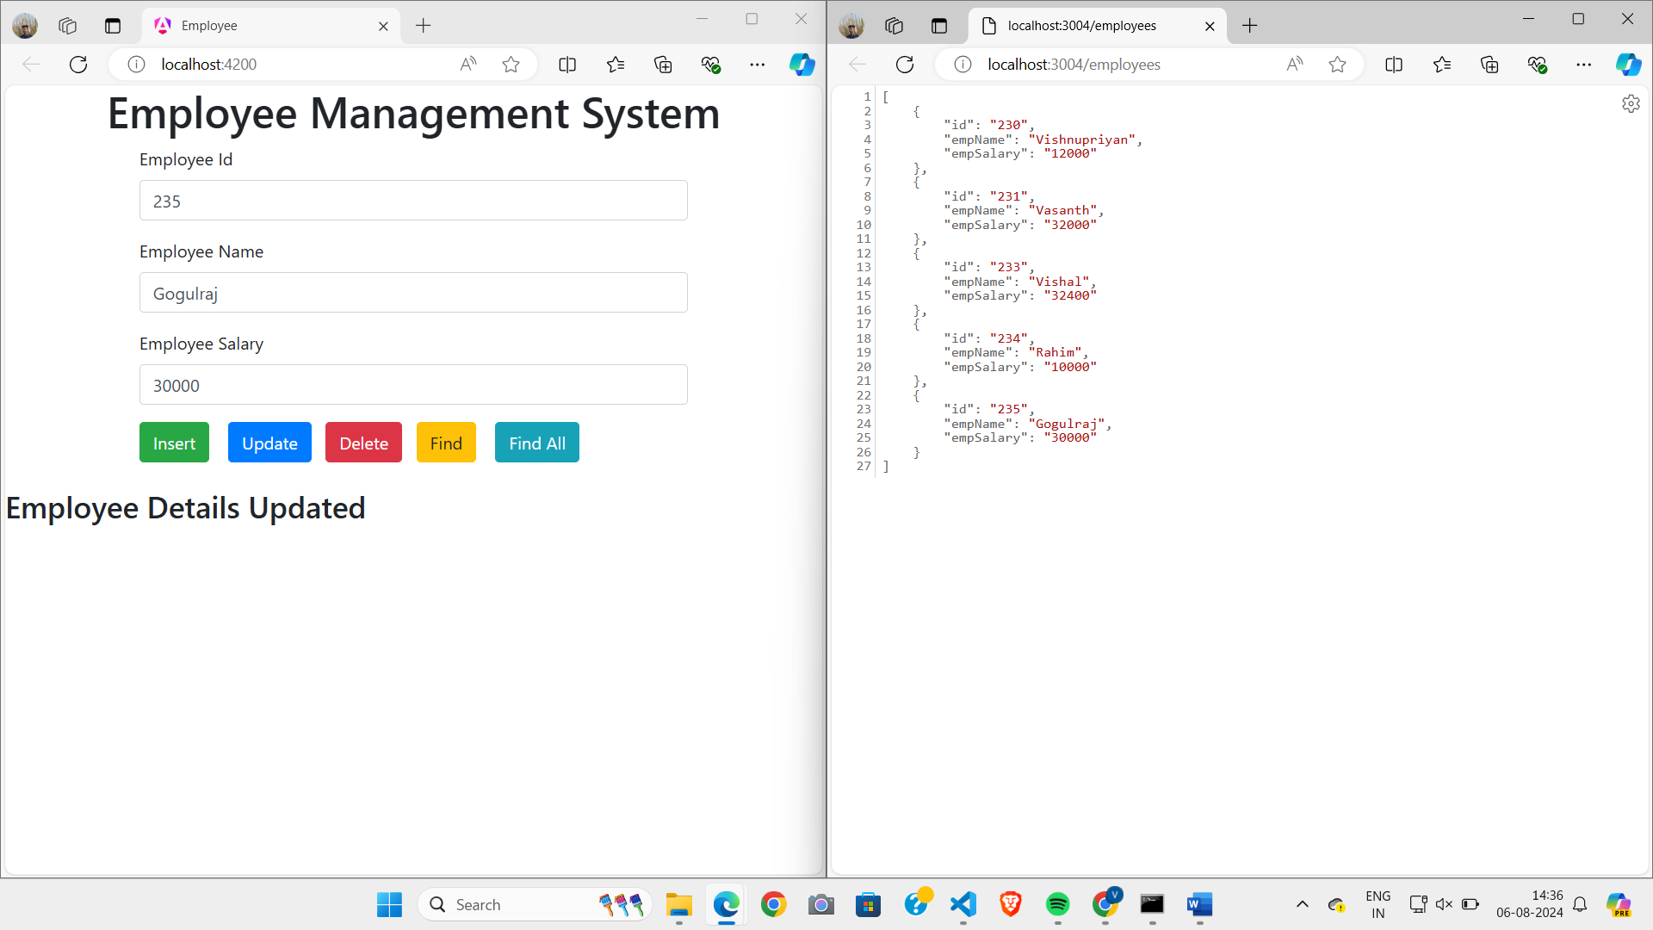

4)Delete the 3rd data:

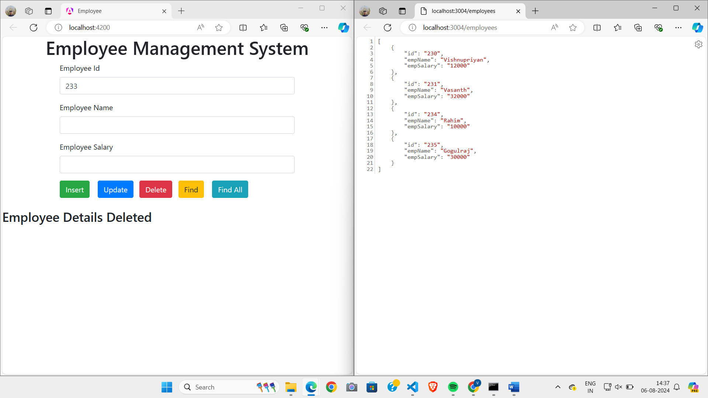

5)Find the 2nd data :

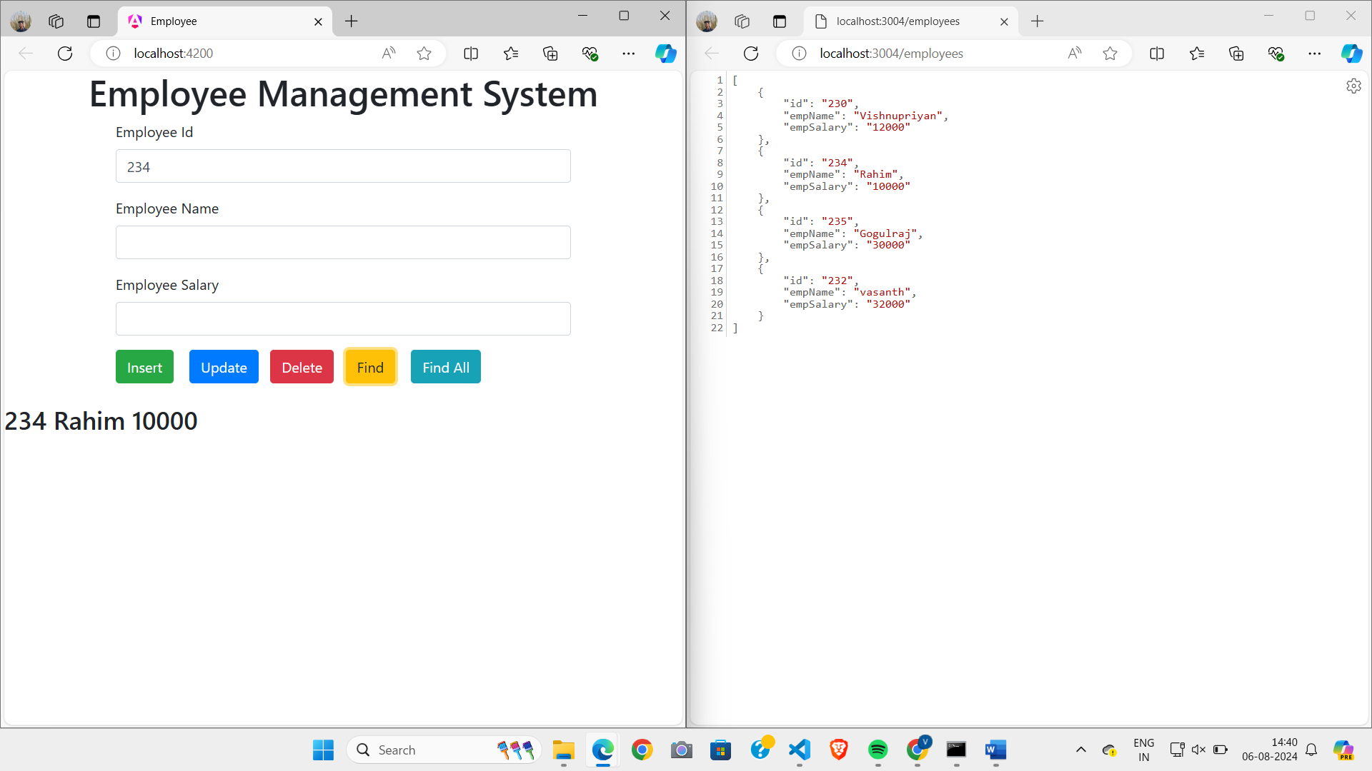

6)Find all the data:

